Pre4A1
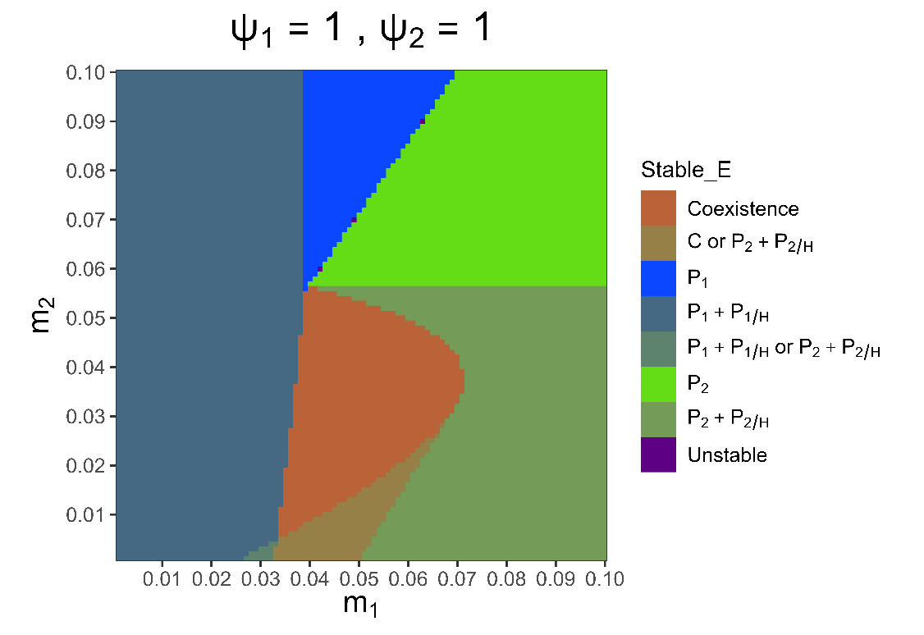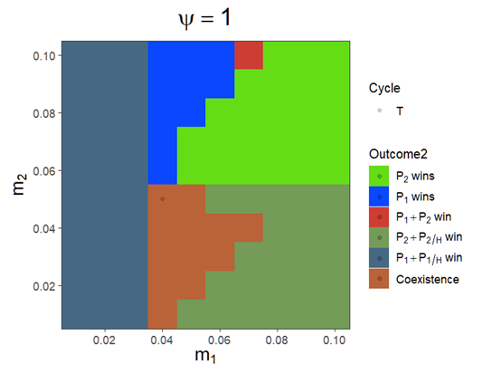
When both $m_{1}$ and $m_{2}$ are small, $P_{1}$ will win the competition due to the less susceptibility to $H$. Plus, because the mortality rate of hyperparasitized pathogens ($P_{i/H}$) is small, there will be more hyperparasites ($H$) contributed by pathogens, and the system has a strong top-down effect.
As $m_{1}$ increases, the high mortality rate results in being less competitive of $P_{1}$, and also reduces the top-down effect that is exerted on $P_{2}$, so the two strains will coexist. If further increase $m_{1}$, then $P_{1}$ will lose the competition, and $P_{2}$ and $P_{2/H}$ will be dominant.

If reducing $h_{i}$ when both $m_{1}$ and $m_{2}$ are small, it can be inferred that the top-down effect will be reduced (because less H is produced) and $P_{2}$ has a greater chance to win the competition or coexist with $P_{1}$.
parms <- list(
r = 1, K = 10,
a1 = 0.35, a2 = 0.5, psi1 = 1, psi2 = 1, e1 = 0.5, e2 = 0.5,
b1 = 0.2, b2 = 0.45, m1 = 0.01, m2 = 0.01, e1H = 0.5, e2H = 0.5,
o1 = 0.8, o2 = 0.8, h1 = 1, h2 = 1, c1 = 0.9, c2 = 0.9, d = 0.03, DL = 0)

> parms <- c(epsilon = 1,
+ r = 1, K = 10,
+ a1 = 0.35, a2 = 0.5, psi1 = 1, psi2 = 1, e1 = 0.5, e2 = 0.5,
+ b1 = 0.2, b2 = 0.45, m1 = 0.01, m2 = 0.01, e1H = 0.5, e2H = 0.5,
+ o1 = 0.8, o2 = 0.8, h1 = 0.95, h2 = 0.95, c1 = 0.9, c2 = 0.9, d = 0.03, DL = 0)

Try to plot the heatmap.

Or we can make $ω_{i}$ become no effect on $P_{i/H}$, so that there will be no top-down effect on both strains:
$$\frac{{dP}_{i/H}}{dt}=β_{i}P_{i}H+δ\left(e_{i/H}{ѱ_{i}α}_{i}P_{i/H}\right)-\left(ω_{i}+m_{i}\right) P_{i/H}$$
Eliminate $ω_{i}$:
$$\frac{{dP}_{i/H}}{dt}=β_{i}P_{i}H+δ\left(e_{i/H}{ѱ_{i}α}_{i}P_{i/H}\right)-m_{i}P_{i/H}$$
$$\frac{dH}{dt}=\sum_{i=1}^{2}{\left(h_{i}ω_{i}P_{i/H}\right)}-\sum_{i=1}^{2}{\left(c_{i}β_{i}P_{i}\right)H-dH}$$
H will still grow due to the contribution of $ω_{i}$, but $ω_{i}$ will not affect $P_{i/H}$.

If doing so, $P_{2}$ will win the competition.
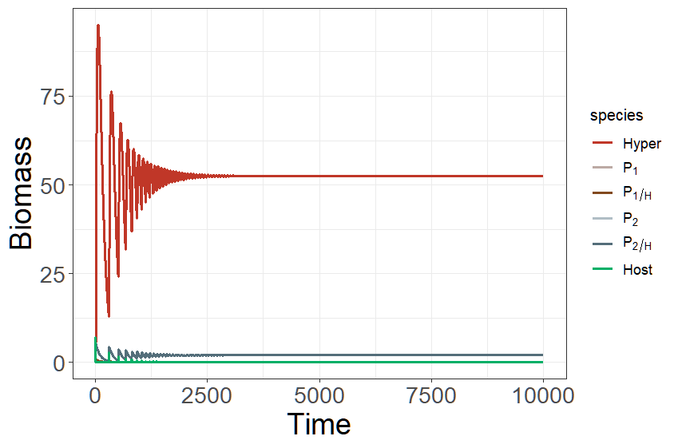
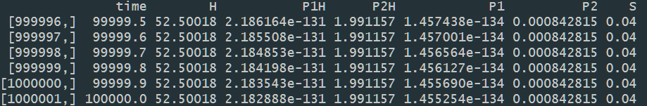

In the original system, $P_{i}$ will become $P_{i/H}$ because of the infection. The more $P_{i/H}$ is, the more $P_{i/H}$ will die of hyperparasite infection. As a result, to erase the effect of $ω_{i}$ on $P_{i/H}$ can indirectly reduce top-down effect.

Use chemostat

When $m_{1}= 0.05$ and $m_{2} = 0.01$, there is an alternative stable state ($E_{C}$ or $E_{2H}$).
Depending on the initial value of each state variable, there will be different outcomes.

When both strains coexist,
H = 0.6716297, P1H = 0.2333761, P2H = 0.1687427, P1 = 1.4767783, P2 = 0.4522385, S = 0.9095539.

When $P_{2}+P_{2/H}$ win,
H = 2.0989911, P2H = 0.8868977, P2 = 0.7605634, S = 1.7626948.

When both strains coexist, it is hard to simply increase $P_{2}$ to collapse the coexistence. Rather, if one increases the abundance of $H$, the equilibrium can switch to the $E_{2H}$.
Try to calculate the minimum abundance to invade the system, i.e., how many H is needed to invade $E_{C}$

